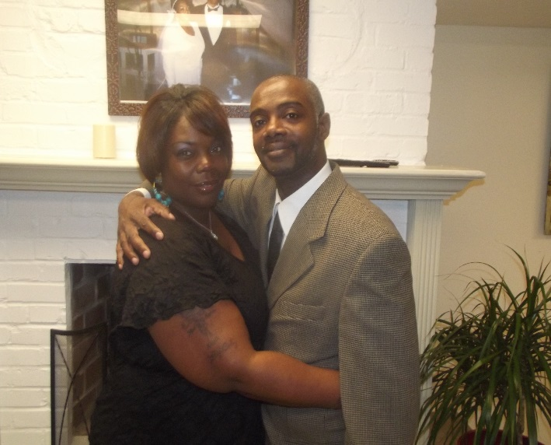
Pastor Anthony
&
Pastor Yvonnya Peoples

GLORY BE TO GOD! I never thought this could be possible until I stepped on the grounds of Victory Gospel Chapel. Too many years of my life going back and forth to jail and selling drugs, us- ing drugs and abusing everything that I came in contact with! I was designed and programmed for failure and fear of the unknown. Even when I entered the doors of Victory Gospel Chapel, fear was there. I didn’t know that greater was coming nor did I know that a plan or a purpose for my life was in progress. I didn’t even care about my life; but today I have Joy. Things have changed through the power of God, the will of God and the love of God, my Elders George and Priscilla Eison, and the anointing on their lives! God has started a work! The work that he started led us to be overseers of one VGC’s Satellite Ministries!
My wife and I go out to reach those who are wounded, lost and beat down by the cares of this world. In this Ministry, we give out food, clothing and prayer through the word of God! As we yoke ourselves to Jesus, we are fervent in telling others that they are not alone and that Jesus loves them. There is a better way through Jesus Christ! God has provided the provisions for the vision, which is winning souls into the kingdom of God! I was never able to depend on anyone, but today I can trust in the lord!
To see the faces of those we minister to, the excitement, the joy, and the anticipation, shows them that they are loved and they are not forgotten. The ministry is a blessing to us and it continues to push us forward in satellite. We have been called to this Ministry for about 2 years and it is a blessing to be a blessing to others through the power of God. We give God all the Glory! We can do nothing without the Holy Spirit leading us into all truth. We thank God for the call to full time Ministry and we are continuously learning to serve God and His people more and more. My wife and I are so grateful to be a part of God’s Ministry called “Satellite.”

